SOP for installing the monitoring agent
Step 1:- https://epc.salam.sa/
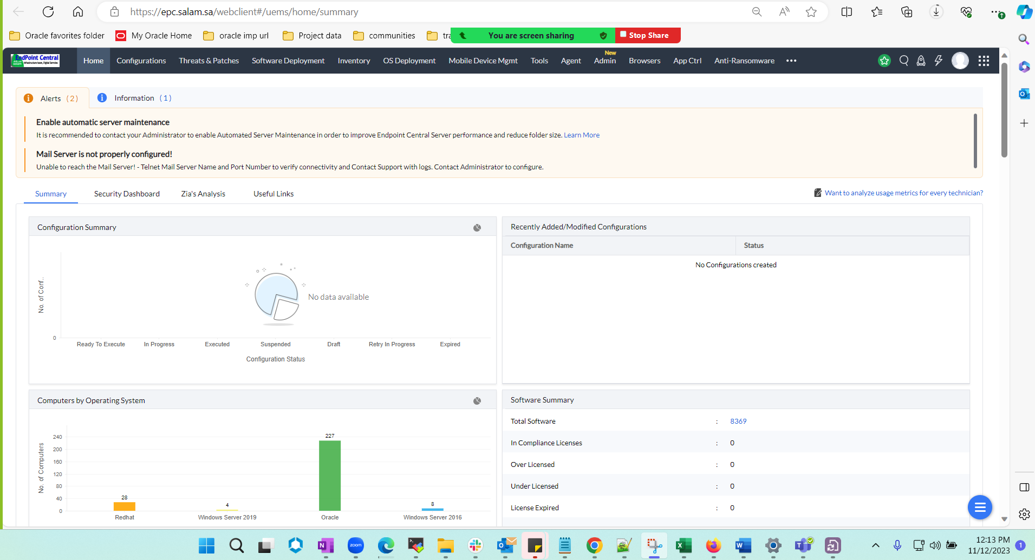
Step 2:- Navigate to inventory tab under manage engine portal select all computers under search option give hostname or ip. Validate if the host exist on the portal.
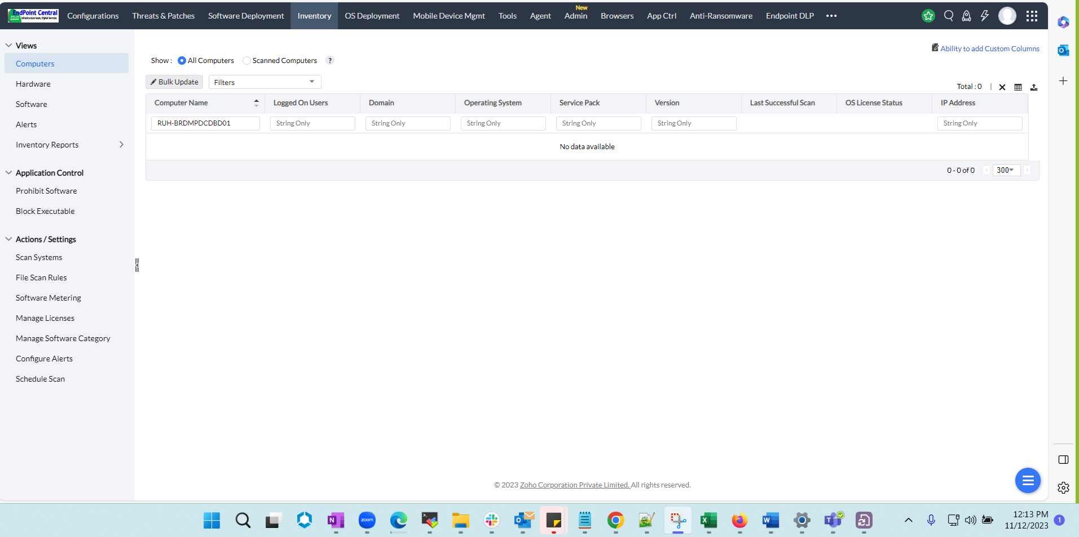
If the host doesn’t exist, please install the agent on the respective servers as mentioned below.
Monitoring agent for linux (zip) is uploaded in ora docs -
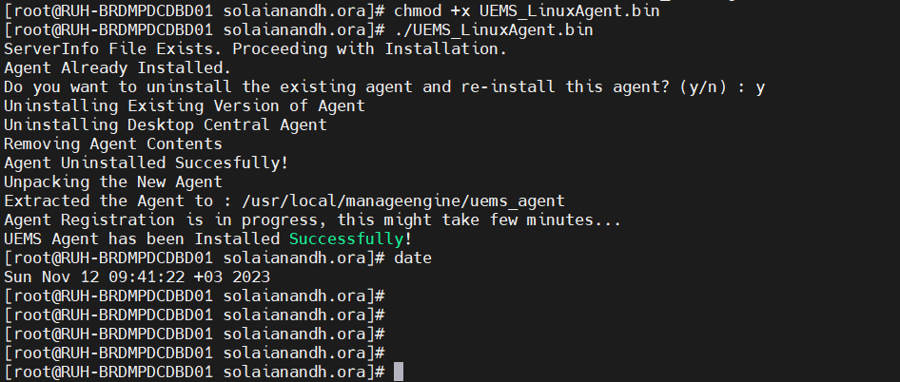
Once the agent is installed successfully please validate the host again on manage engine portal
